LGBTQIA+ Flag… | What the flag means…
Gay
A non-woman who is emotionally and sexually attracted to other non-women. Can also apply to non-binary people.
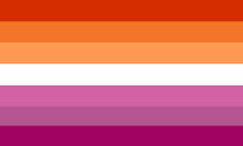 | Lesbian  A non-man who is emotionally and sexually attracted to other non-men. Can also apply to non-binary people.
Bisexual
A person of any gender that is emotionally and sexually attracted to one or more genders. Commonly confused with pansexual.
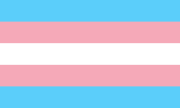 | Transgender  A person whose gender identity does not match the one they were assigned at birth. Transgender people do not need to have had surgery to identify as such, and they can identify with any sexual orientation.
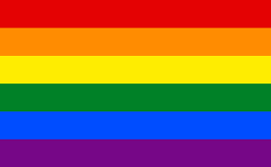 | Queer  An umbrella term for the LGBTQIA+ community. It was once a slur, but has now been reclaimed to celebrate people who are part of the LGBTQIA+ community. This flag is incorrectly known as the gay flag.
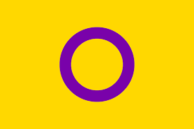 | Intersex  A person who is born with alternative genitals, chromosomes or sexual organs than their assigned gender. People do not identify as intersex, it is instead a biological variation that occurs.
Asexual
A person who lacks a sexual attraction to other people. They may however still desire emotional relationships with other people of any gender. This however comes on a spectrum, and is different for everyone.
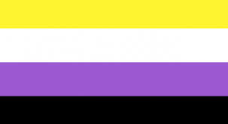 | Non-Binary  A person who doesn’t identify as either male or female. They may identify as both genders, somewhere in between, or neither. Can be used as an umbrella term for people who are agender, bigender, genderqueer or gender-fluid
Pansexual
A person of any gender who is attracted to everyone regardless of their gender, unlike bisexual which is when someone is only attracted to a certain amount of genders.

Pride Flags – Intersex Flag

A person who is born with alternative genitals, chromosomes or sexual organs than their assigned gender. People do not identify as intersex, it is instead a biological variation that occurs. People who are intersex can be any orientation, and any gender, as their gender isn’t defined by their chromosome or sexual organs. Intersex is an umbrella term used to describe a wide range of natural bodily variations.
----------
Most of the time when a baby is born intersex, doctors and the family decide on a sex, either male or female, and raise the baby as the gender expected of that sex. It’s pretty common for surgery to be done on the baby’s genitals and also for the child to be given hormones to make them fit into male/female categories as they go through puberty.
----------

However, activism for intersex people is growing, leading to some changes in our culture, which right now treats intersex as a medical problem instead of a natural, healthy way bodies can be. Today, more and more people believe unnecessary surgery and other medical interventions shouldn’t be done on intersex babies and children at all.

