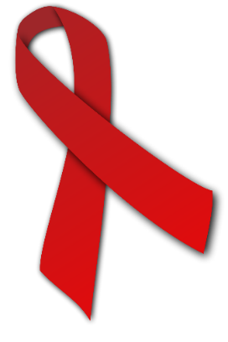

*Summary*

HIV is a disease that attacks the body’s immune system, and if not treated can **develop into AIDs** (which is where the body’s immune system is so weakened by the HIV virus that life-threatening illnesses can be developed, e.g. pneumonia)

The epidemic massively affected the whole Queer Community **(but predominantly queer men)** when it appeared in the early 1980s, and it was more transmittable by men than by women. Calls were made to halt the advances of LGBTQ+ rights, because **many blamed the queer community for the spread of the disease**.

While it most commonly affects queer people, many straight people also have AIDs, with some not even knowing they have the virus

*Damage to the LGBTQ+ Community*

LGBTQ+ people face specific challenges and barriers, including violence, human rights violations, stigma and discrimination. **Criminalisation of same-sex relationships, cross-dressing and ‘gender impersonation’ feeds into ‘social homophobia’** and these factors prevent LGBT people from accessing vital STD prevention, testing, and treatment. The emergence of HIV only furthered the discrimination that gay people received, and seemed to justified the harassment, abuse and assault of queer people

*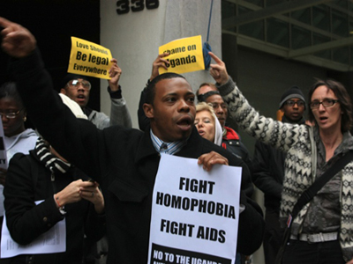***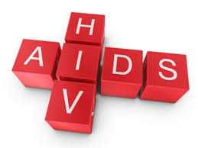**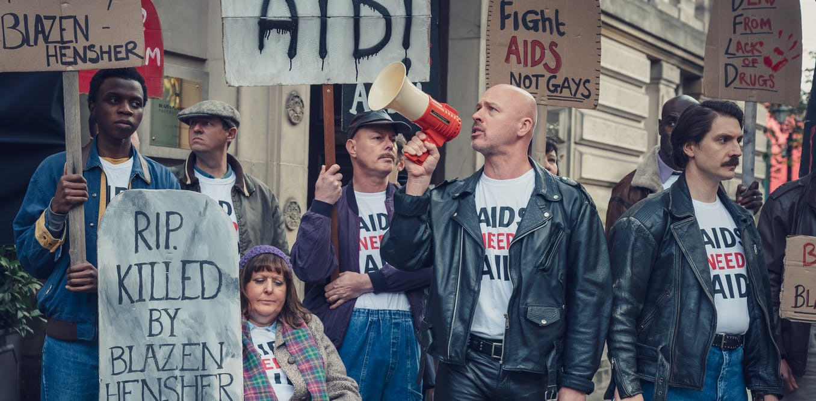

*Initial Societal Reactions*

Ronald Reagen’s Press Secretary Larry Speakes & a room of reporters (In 1982)… **“It’s known as gay plague,” a journalist asked. Some people in the room chuckled. “I don’t have it, do you?” Speakes snapped back, as the room erupted in laughter. "Do you? You didn't answer my question. How do you know?”**

The UK newspapers titled stories about AIDs, the **‘gay plague’**, **‘Gas gays says Tory’**, and **‘gay cancer’** clearly tarnishing the Queer community’s reputation.

The NHS tried to create sanctuary for people living with HIV, but the press would try to invade it. One nurse said that journalists often posed as visitors to get information about HIV positive patients.

*AIDs in Modern Day*

Treatments have been created for those with HIV/AIDs, so they can have healthy relationships without the chance of spreading the disease (six-time-a-year injection, daily tablet). PrEP is a tablet people can take so that they can have relationships with the partner without the risk of infection.

The virus also had so much stigma that men in queer relationships were unable to give blood without delay until **JUNE THIS YEAR.**

**1 in 8 people with HIV around the world** are denied healthcare based on the fact they have the virus, showing how the world still has a distance to go to give people with AIDs equality.