HARVEY MILK - USA
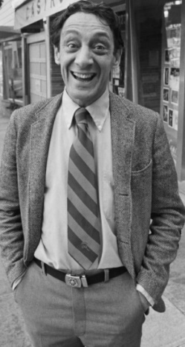
Harvey Milk was the first openly gay elected official in California. He got involved in local politics and activism after moving from New York City to San Francisco. He ran twice for a position on the San Francisco Board of Supervisors and lost both races. He won a spot on the City-County Board in 1977 after earning the nickname "Mayor of Castro Street,". Milk spent his time on the board working on many issues including gay rights before his assassination in November 1978.

MARSHA P JOHNSON - USA
Marsha P Johnson was an American black transgender woman, queer liberation activist and drag queen. Known as an outspoken advocate for gay rights. Johnson was one of the prominent figures in the Stonewall uprising of 1969, and is one of the people responsible for creating Pride celebrations in American and across the world.

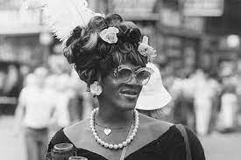

CHRIS SMITH - UK
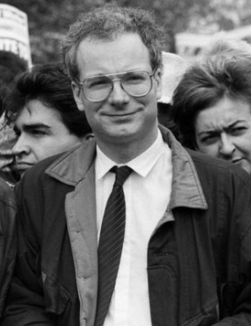
In 1984 Chris Smith became the UK's first male openly gay MP and later, the first gay cabinet minister.
After announcing that he was gay, he received a five-minute standing ovation. His actions and the positive reaction he received has undoubtedly helped pave the way for many other MPs to be open about their sexuality as well.
There are currently 54 LGBT MPs in the House of Commons, and in 2015 it was declared the gayest parliament in the world due to its proportion of LBGBT members
QUEER EYE’S FAB 5 - USA
The “Fab Five” — Tan France, Jonathan Van Ness, Bobby Berk, Karamo Brown, and Antoni Porowski — speak openly on Queer Eye about their personal struggles and experiences with homophobia and discrimination. And the stars hope to use their newfound fame to empower LGBTQ communities.
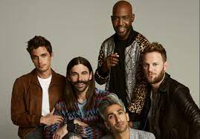

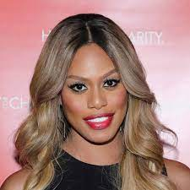
LAVERNE COX - USA
Laverne Cox is an American actress and LGBT Advocate who rose to prominence with her role in ‘Orange is the New Black’. She was the first transgender person to be nominated for a Primetime Emmy Award in an acting category, and the first trans person to be nominated since composer Angela Morley in 1990. She has starred in other pieces of queer media too, such as the documentary ‘Disclosure’ which explores the lives of real transgender people and their struggles during a time where their identity is consistently questioned.
TOM DALEY - UK
Tom Daley is a British Diver and television personality who won a gold medal at the Tokyo 2020 Olympic Games. He is openly gay and is a well-known queer activist. He has been married to his husband Dustin Lance Black since 2017 and the two of them had their son Robbie via surrogacy in 2018. In October 2021, he said he would make it his "mission" to campaign for countries where homosexuality is punishable by death to be banned from the next Olympics.

