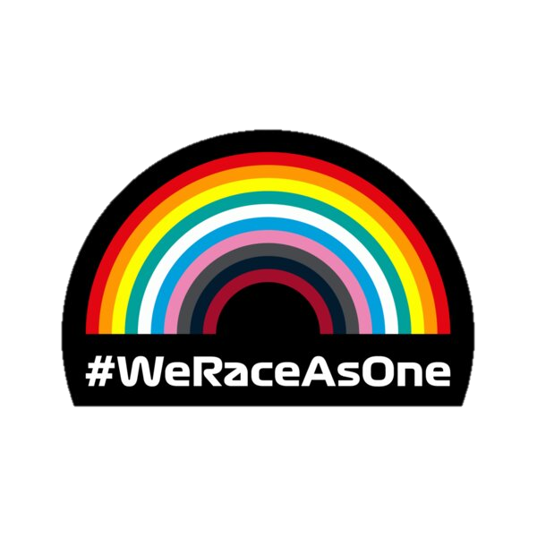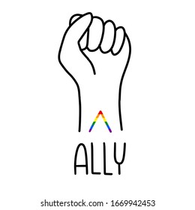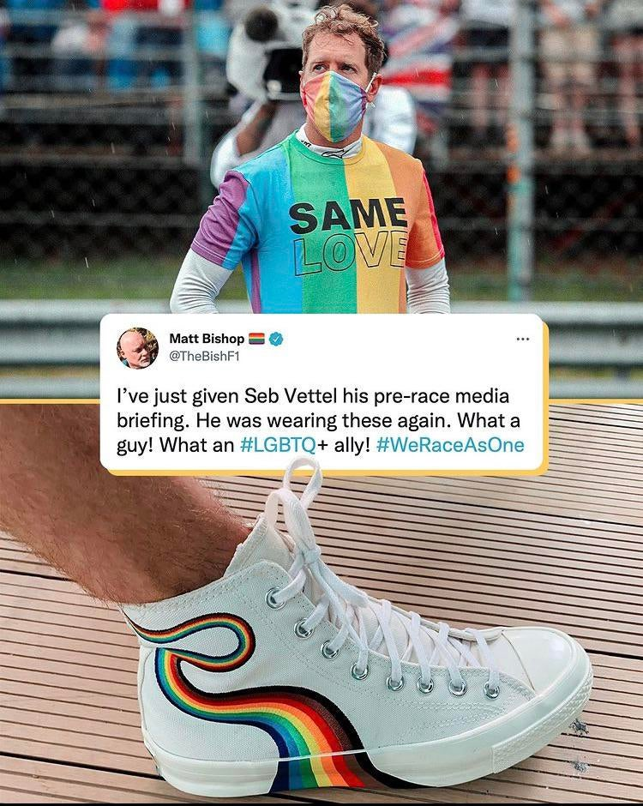SEBASTIAN VETT EL

In 2021 he was very outspoken about the laws that had just been introduced in Hungary that suppressed the LGBTQ+ community. He did the same in Saudi Arabia later in the year, adding women’s rights to the argument.

When highlighting the discrimination in a country, Vettel has showed off many colourful designs (shown to the right) which have helped the media to focus on him during these events to make sure the government see him making a statement.

Sebastian Vettel is an F1 Driver who has been very open and public about the inequality in laws against women and members of the LGBTQ+ community in countries where the sport races at.