The reason we have pride is to commemorate the Stonewall Riots of 1969, where police raided the Stonewall Inn in New York, a gay club, and mass demonstrations were made all across the country in response the violent treatment gay staff and customers had to endure during the raid.

**Why do we need Pride?**

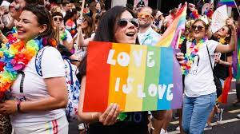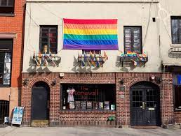

Pride is a celebration of sexuality and gender identity & expression, where the LGBTQ+ community can celebrate their identities as queer people, and where allies can show their support for their them.

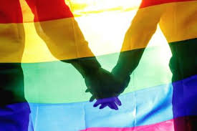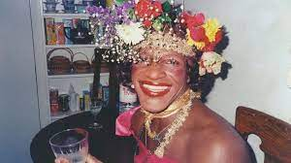

Being gay is still a criminal offence in almost 70 countries across the world. Pride shows that while we still have a long way to go to gain equality, we have made massive progress, and we should appreciate those who paved the way to help us gain that equality such as Marsha P Johnson & Harvey Milk)

We don’t have straight pride, because Queer people have experienced prejudice, discrimination and violence purely because of their sexuality. Straight people are still welcome to show their solidarity as pride though.